**CODING ASSIGNMENT**

**BURGER BASH**









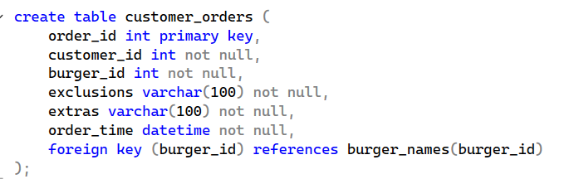

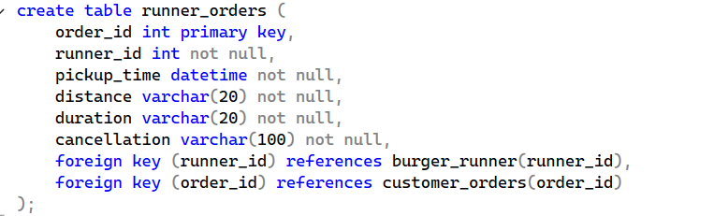



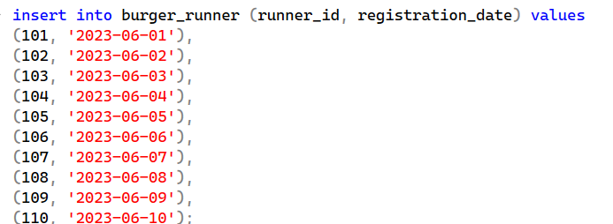

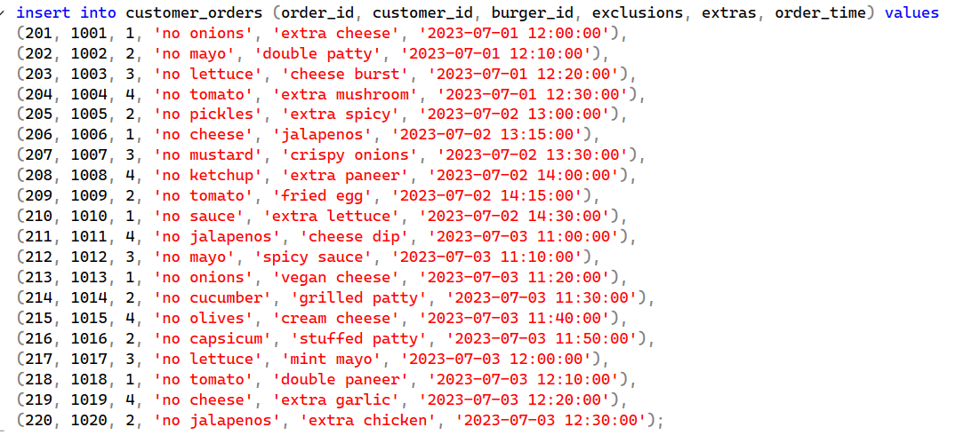

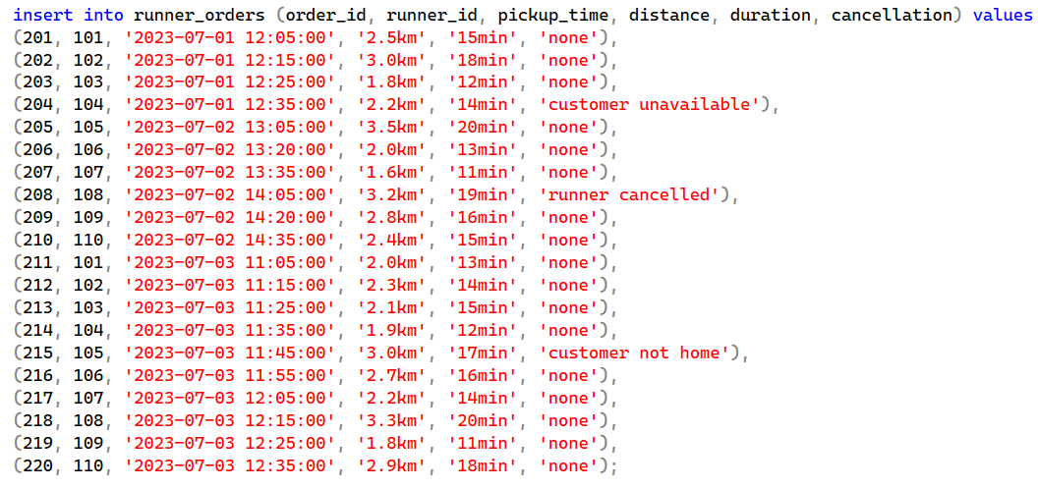

**-- 1. Count how many burgers were ordered**

select count(*) as total_burgers_ordered from customer_orders;

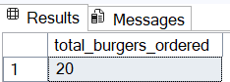

**-- 2. Count how many unique customer orders were made**

select count(distinct order_id) as unique_customer_orders from customer_orders;

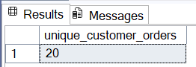

**-- 3. Count how many successful orders were delivered by each runner**

select runner_id, count(*) as successful_deliveries from runner_orders where cancellation is null or lower(cancellation) = 'none' group by runner_id;

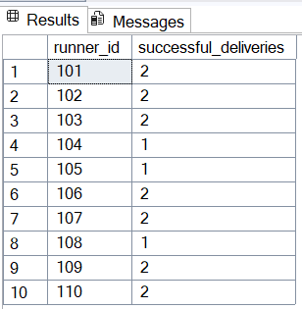

**-- 4. Count how many of each type of burger was delivered**

select b.burger_name, count(*) as delivery_count from customer_orders c join runner_orders r on c.order_id = r.order_id join burger_names b on c.burger_id = b.burger_id where r.cancellation is null or lower(r.cancellation) = 'none' group by b.burger_name;

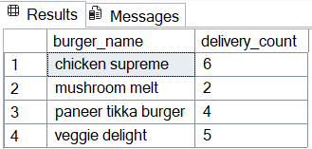

**-- 5. Count how many Vegetarian and Meatlovers burgers were ordered by each customer**

select customer_id, sum(case when burger_id in (1, 3, 4) then 1 else 0 end) as vegetarian_count, sum(case when burger_id = 2 then 1 else 0 end) as meatlovers_count from customer_orders group by customer_id;

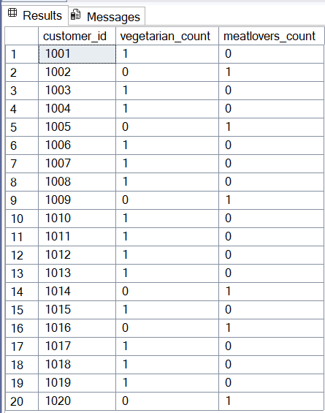

**-- 6. Get the maximum number of burgers delivered in a single order**

select top 1 c.order_id, count(*) as burgers_count from customer_orders c join runner_orders r on c.order_id = r.order_id where r.cancellation is null or lower(r.cancellation) = 'none' group by c.order_id order by burgers_count desc;

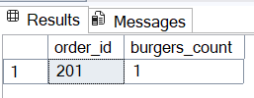

**-- 7. For each customer, count how many delivered burgers had at least 1 change and how many had no changes**

select customer_id, sum(case when (exclusions is not null and exclusions <> '') or (extras is not null and extras <> '') then 1 else 0 end) as changed_burgers, sum(case when (exclusions is null or exclusions = '') and (extras is null or extras = '') then 1 else 0 end) as no_change_burgers from customer_orders c join runner_orders r on c.order_id = r.order_id where r.cancellation is null or lower(r.cancellation) = 'none' group by customer_id;

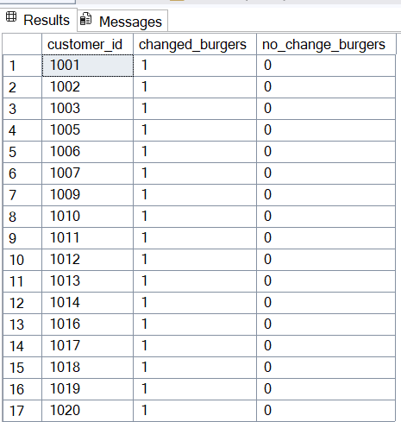

**-- 8. Show the total volume of burgers ordered for each hour of the day**

select datepart(hour, order_time) as order_hour, count(*) as burgers_ordered from customer_orders group by datepart(hour, order_time) order by order_hour;

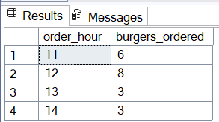

**-- 9. Show how many runners signed up for each 1 week period**

select datepart(week, registration_date) as week_number, count(*) as runners_signed_up from burger_runner group by datepart(week, registration_date) order by week_number;

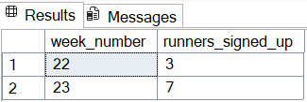

**-- 10. Get the average distance travelled for each customer**

select c.customer_id, avg(cast(replace(r.distance, 'km', '') as float)) as avg_distance_km from customer_orders c join runner_orders r on c.order_id = r.order_id where r.cancellation is null or lower(r.cancellation) = 'none' group by c.customer_id;

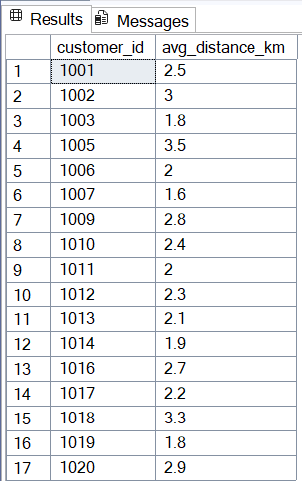

**-- Complex Query 1: Most active runners with max total distance**

SELECT TOP 5 r.runner_id, SUM(CAST(REPLACE(r.distance, 'km', '') AS FLOAT)) AS total_kms FROM runner_orders r WHERE r.cancellation IS NULL OR LOWER(r.cancellation) = 'none' GROUP BY r.runner_id ORDER BY total_kms DESC;

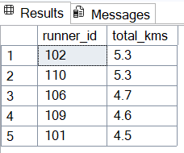

**-- Complex Query 2: Burger type popularity per day**

SELECT CAST(order_time AS DATE) AS order_date, b.burger_name, COUNT(*) AS total_orders FROM customer_orders c JOIN burger_names b ON c.burger_id = b.burger_id GROUP BY CAST(order_time AS DATE), b.burger_name ORDER BY order_date, total_orders DESC;

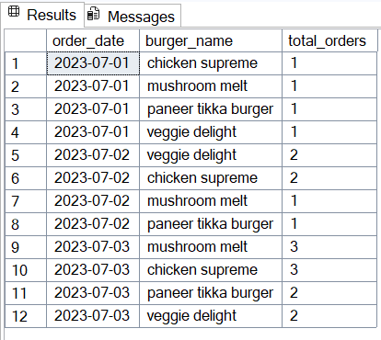

**-- Complex Query 3: Average duration of delivery by burger type (only successful)**

SELECT b.burger_name, AVG(CAST(REPLACE(r.duration, 'min', '') AS FLOAT)) AS avg_duration_minutes FROM customer_orders c JOIN runner_orders r ON c.order_id = r.order_id JOIN burger_names b ON c.burger_id = b.burger_id WHERE r.cancellation IS NULL OR LOWER(r.cancellation) = 'none' GROUP BY b.burger_name ORDER BY avg_duration_minutes;

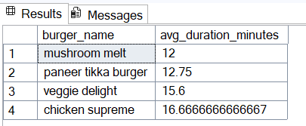

**-- Complex Query 4: Number of cancelled orders by reason**

SELECT LOWER(cancellation) AS cancel_reason, COUNT(*) AS total_cancellations FROM runner_orders WHERE cancellation IS NOT NULL AND LOWER(cancellation) <> 'none' GROUP BY LOWER(cancellation);

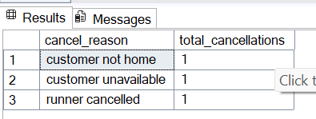

**-- Complex Query 5: Rank runners by number of deliveries per day**

SELECT CAST(pickup_time AS DATE) AS delivery_date, runner_id, COUNT(*) AS deliveries, RANK() OVER (PARTITION BY CAST(pickup_time AS DATE) ORDER BY COUNT(*) DESC) AS delivery_rank FROM runner_orders WHERE cancellation IS NULL OR LOWER(cancellation) = 'none' GROUP BY CAST(pickup_time AS DATE), runner_id ORDER BY delivery_date, delivery_rank;

